|  |
| --- |
| Описание: Описание: для прик эмбл |
| МИНОБРНАУКИ РОССИИ |
| Федеральное государственное бюджетное образовательное учреждение  высшего профессионального образования  **"Российский технологический университет"**  **МИРЭА** |
| Институт «Комплексной безопасности и специального приборостроения» |
| Кафедра «Управление и моделирование систем» (КБ-3) |
|  |

|  |  |
| --- | --- |
| **Практика №2 по дисциплине** | |
|  | |
| **« Основы информационной безопасности »**  **МЕТАДАННЫЕ** | |
|  | |
| Выполнила студентка группы БИСО-03-19 | Пашенцева В.Н. |

Москва 2020

**Задание 1.**

Фото:

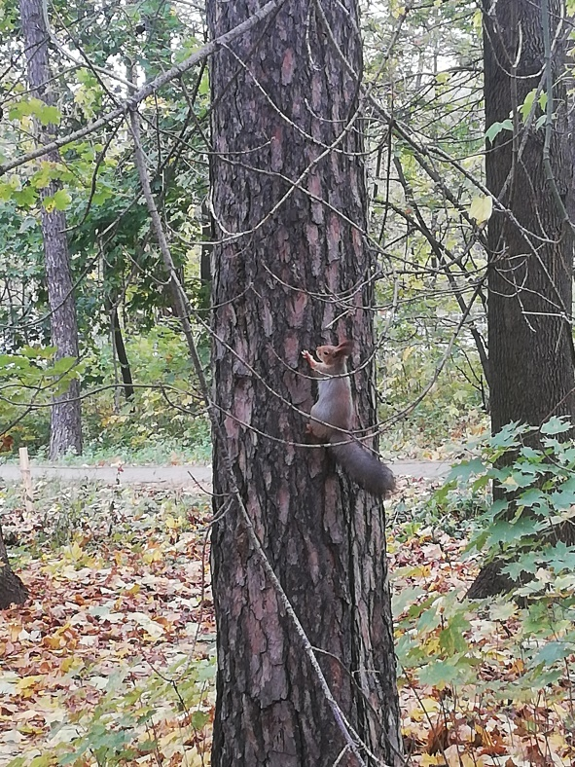

|  |  |
| --- | --- |
| **create** | 2020-11-27T21:22:04+00:00 |
| ApertureValue | 227/100 |
| BrightnessValue | 0/1 |
| ColorSpace | 1 |
| Contrast | 0 |
| DateTime | 2020:10:21 10:19:13 |
| DateTimeDigitized | 2020:10:21 10:19:13 |
| DateTimeOriginal | 2020:10:21 10:19:13 |
| DigitalZoomRatio | 1/1 |
| ExifImageLength | 4608 |
| ExifImageWidth | 3456 |
| ExifOffset | 218 |
| ExifVersion | 0210 |
| ExposureBiasValue | 0/1 |
| ExposureMode | 0 |
| ExposureProgram | 2 |
| ExposureTime | 833/49979 |
| FileSource | 0 |
| Flash | 0 |
| FlashPixVersion | 0100 |
| FNumber | 11/5 |
| FocalLength | 381/100 |
| FocalLengthIn35mmFilm | 102 |
| GainControl | 0 |
| GPSAltitude | 9129/50 |
| GPSAltitudeRef | 0 |
| GPSDateStamp | 2020:10:21 |
| GPSDestBearing | 0/1 |
| GPSDestDistance | 0/1 |
| GPSDestLatitude | 0/1, 0/1, 0/1 |
| GPSDestLongitude | 0/1, 0/1, 0/1 |
| GPSDop | 0/1 |
| GPSImgDirection | 0/1 |
| GPSInfo | 836 |
| GPSLatitude | 55/1, 48/1, 341471/8713 |
| GPSLatitudeRef | N |
| GPSLongitude | 37/1, 28/1, 537912/10163 |
| GPSLongitudeRef | E |
| GPSSpeed | 0/1 |
| GPSTimeStamp | 7/1, 19/1, 7/1 |
| GPSTrack | 0/1 |
| GPSVersionID | 2, 2, 0, 0 |
| ImageDescription | dig |
| ISOSpeedRatings | 160 |
| LightSource | 1 |
| Make | HUAWEI |
| MeteringMode | 5 |
| Model | RNE-L21 |
| Orientation | 0 |
| ResolutionUnit | 2 |
| Saturation | 0 |
| SceneCaptureType | 0 |
| SceneType | 0 |
| SensingMethod | 2 |
| Sharpness | 0 |
| ShutterSpeedValue | 298973/10000 |
| Software | RNE-L21 8.0.0.343(C10) |
| SubjectDistanceRange | 0 |
| SubSecTime | 766818 |
| SubSecTimeDigitized | 766818 |
| SubSecTimeOriginal | 766818 |
| WhiteBalance | 0 |
| XResolution | 72/1 |
| YCbCrPositioning | 1 |
| YResolution | 72/1 |
| **modify** | 2020-11-27T21:22:04+00:00 |
| ApertureValue | 227/100 |
| BrightnessValue | 0/1 |
| ColorSpace | 1 |
| Contrast | 0 |
| DateTime | 2020:10:21 10:19:13 |
| DateTimeDigitized | 2020:10:21 10:19:13 |
| DateTimeOriginal | 2020:10:21 10:19:13 |
| DigitalZoomRatio | 1/1 |
| ExifImageLength | 4608 |
| ExifImageWidth | 3456 |
| ExifOffset | 218 |
| ExifVersion | 0210 |
| ExposureBiasValue | 0/1 |
| ExposureMode | 0 |
| ExposureProgram | 2 |
| ExposureTime | 833/49979 |
| FileSource | 0 |
| Flash | 0 |
| FlashPixVersion | 0100 |
| FNumber | 11/5 |
| FocalLength | 381/100 |
| FocalLengthIn35mmFilm | 102 |
| GainControl | 0 |
| GPSAltitude | 9129/50 |
| GPSAltitudeRef | 0 |
| GPSDateStamp | 2020:10:21 |
| GPSDestBearing | 0/1 |
| GPSDestDistance | 0/1 |
| GPSDestLatitude | 0/1, 0/1, 0/1 |
| GPSDestLongitude | 0/1, 0/1, 0/1 |
| GPSDop | 0/1 |
| GPSImgDirection | 0/1 |
| GPSInfo | 836 |
| GPSLatitude | 55/1, 48/1, 341471/8713 |
| GPSLatitudeRef | N |
| GPSLongitude | 37/1, 28/1, 537912/10163 |
| GPSLongitudeRef | E |
| GPSSpeed | 0/1 |
| GPSTimeStamp | 7/1, 19/1, 7/1 |
| GPSTrack | 0/1 |
| GPSVersionID | 2, 2, 0, 0 |
| ImageDescription | dig |
| ISOSpeedRatings | 160 |
| LightSource | 1 |
| Make | HUAWEI |
| MeteringMode | 5 |
| Model | RNE-L21 |
| Orientation | 0 |
| ResolutionUnit | 2 |
| Saturation | 0 |
| SceneCaptureType | 0 |
| SceneType | 0 |
| SensingMethod | 2 |
| Sharpness | 0 |
| ShutterSpeedValue | 298973/10000 |
| Software | RNE-L21 8.0.0.343(C10) |
| SubjectDistanceRange | 0 |
| SubSecTime | 766818 |
| SubSecTimeDigitized | 766818 |
| SubSecTimeOriginal | 766818 |
| WhiteBalance | 0 |
| XResolution | 72/1 |
| YCbCrPositioning | 1 |
| YResolution | 72/1 |
| **colorspace** | 2 |
| ApertureValue | 227/100 |
| BrightnessValue | 0/1 |
| ColorSpace | 1 |
| Contrast | 0 |
| DateTime | 2020:10:21 10:19:13 |
| DateTimeDigitized | 2020:10:21 10:19:13 |
| DateTimeOriginal | 2020:10:21 10:19:13 |
| DigitalZoomRatio | 1/1 |
| ExifImageLength | 4608 |
| ExifImageWidth | 3456 |
| ExifOffset | 218 |
| ExifVersion | 0210 |
| ExposureBiasValue | 0/1 |
| ExposureMode | 0 |
| ExposureProgram | 2 |
| ExposureTime | 833/49979 |
| FileSource | 0 |
| Flash | 0 |
| FlashPixVersion | 0100 |
| FNumber | 11/5 |
| FocalLength | 381/100 |
| FocalLengthIn35mmFilm | 102 |
| GainControl | 0 |
| GPSAltitude | 9129/50 |
| GPSAltitudeRef | 0 |
| GPSDateStamp | 2020:10:21 |
| GPSDestBearing | 0/1 |
| GPSDestDistance | 0/1 |
| GPSDestLatitude | 0/1, 0/1, 0/1 |
| GPSDestLongitude | 0/1, 0/1, 0/1 |
| GPSDop | 0/1 |
| GPSImgDirection | 0/1 |
| GPSInfo | 836 |
| GPSLatitude | 55/1, 48/1, 341471/8713 |
| GPSLatitudeRef | N |
| GPSLongitude | 37/1, 28/1, 537912/10163 |
| GPSLongitudeRef | E |
| GPSSpeed | 0/1 |
| GPSTimeStamp | 7/1, 19/1, 7/1 |
| GPSTrack | 0/1 |
| GPSVersionID | 2, 2, 0, 0 |
| ImageDescription | dig |
| ISOSpeedRatings | 160 |
| LightSource | 1 |
| Make | HUAWEI |
| MeteringMode | 5 |
| Model | RNE-L21 |
| Orientation | 0 |
| ResolutionUnit | 2 |
| Saturation | 0 |
| SceneCaptureType | 0 |
| SceneType | 0 |
| SensingMethod | 2 |
| Sharpness | 0 |
| ShutterSpeedValue | 298973/10000 |
| Software | RNE-L21 8.0.0.343(C10) |
| SubjectDistanceRange | 0 |
| SubSecTime | 766818 |
| SubSecTimeDigitized | 766818 |
| SubSecTimeOriginal | 766818 |
| WhiteBalance | 0 |
| XResolution | 72/1 |
| YCbCrPositioning | 1 |
| YResolution | 72/1 |
| **sampling-factor** | 2x2,1x1,1x1 |
| ApertureValue | 227/100 |
| BrightnessValue | 0/1 |
| ColorSpace | 1 |
| Contrast | 0 |
| DateTime | 2020:10:21 10:19:13 |
| DateTimeDigitized | 2020:10:21 10:19:13 |
| DateTimeOriginal | 2020:10:21 10:19:13 |
| DigitalZoomRatio | 1/1 |
| ExifImageLength | 4608 |
| ExifImageWidth | 3456 |
| ExifOffset | 218 |
| ExifVersion | 0210 |
| ExposureBiasValue | 0/1 |
| ExposureMode | 0 |
| ExposureProgram | 2 |
| ExposureTime | 833/49979 |
| FileSource | 0 |
| Flash | 0 |
| FlashPixVersion | 0100 |
| FNumber | 11/5 |
| FocalLength | 381/100 |
| FocalLengthIn35mmFilm | 102 |
| GainControl | 0 |
| GPSAltitude | 9129/50 |
| GPSAltitudeRef | 0 |
| GPSDateStamp | 2020:10:21 |
| GPSDestBearing | 0/1 |
| GPSDestDistance | 0/1 |
| GPSDestLatitude | 0/1, 0/1, 0/1 |
| GPSDestLongitude | 0/1, 0/1, 0/1 |
| GPSDop | 0/1 |
| GPSImgDirection | 0/1 |
| GPSInfo | 836 |
| GPSLatitude | 55/1, 48/1, 341471/8713 |
| GPSLatitudeRef | N |
| GPSLongitude | 37/1, 28/1, 537912/10163 |
| GPSLongitudeRef | E |
| GPSSpeed | 0/1 |
| GPSTimeStamp | 7/1, 19/1, 7/1 |
| GPSTrack | 0/1 |
| GPSVersionID | 2, 2, 0, 0 |
| ImageDescription | dig |
| ISOSpeedRatings | 160 |
| LightSource | 1 |
| Make | HUAWEI |
| MeteringMode | 5 |
| Model | RNE-L21 |
| Orientation | 0 |
| ResolutionUnit | 2 |
| Saturation | 0 |
| SceneCaptureType | 0 |
| SceneType | 0 |
| SensingMethod | 2 |
| Sharpness | 0 |
| ShutterSpeedValue | 298973/10000 |
| Software | RNE-L21 8.0.0.343(C10) |
| SubjectDistanceRange | 0 |
| SubSecTime | 766818 |
| SubSecTimeDigitized | 766818 |
| SubSecTimeOriginal | 766818 |
| WhiteBalance | 0 |
| XResolution | 72/1 |
| YCbCrPositioning | 1 |
| YResolution | 72/1 |

**Задание 2.**

Выбран сайт: <https://www.bbc.com/>





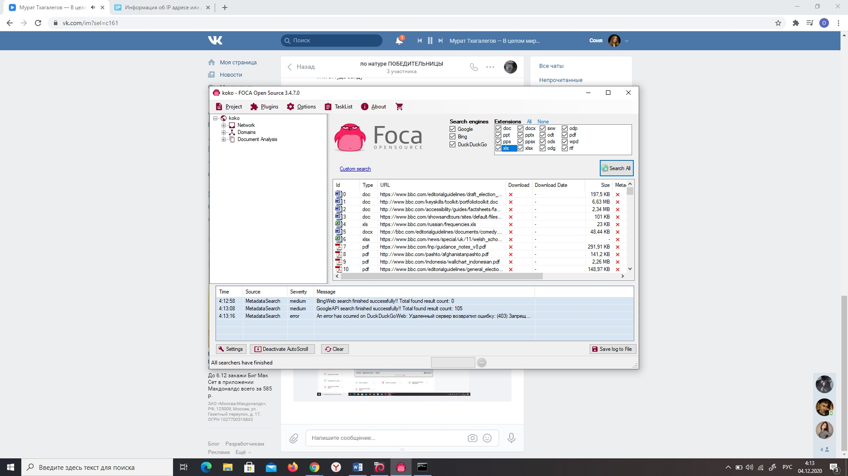

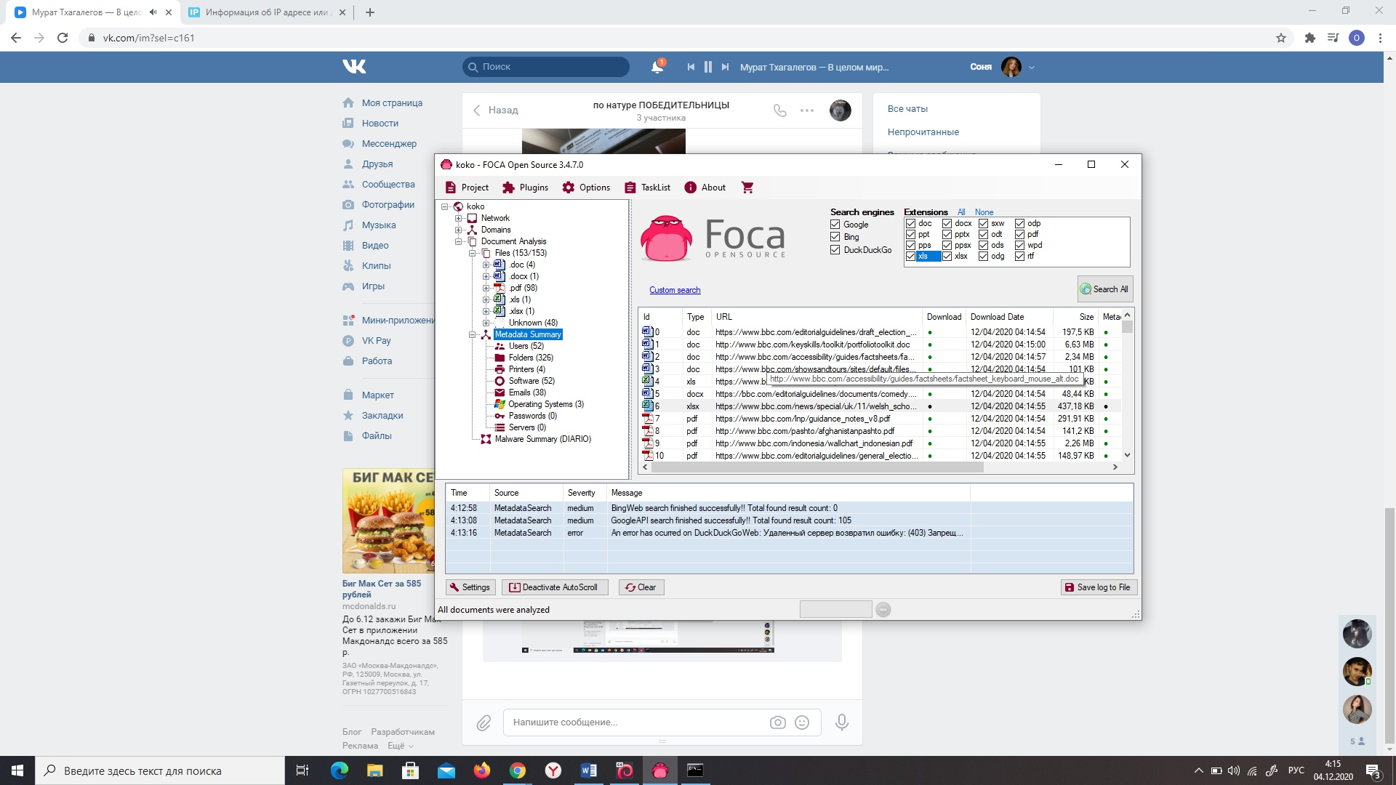

**Задание 3.**

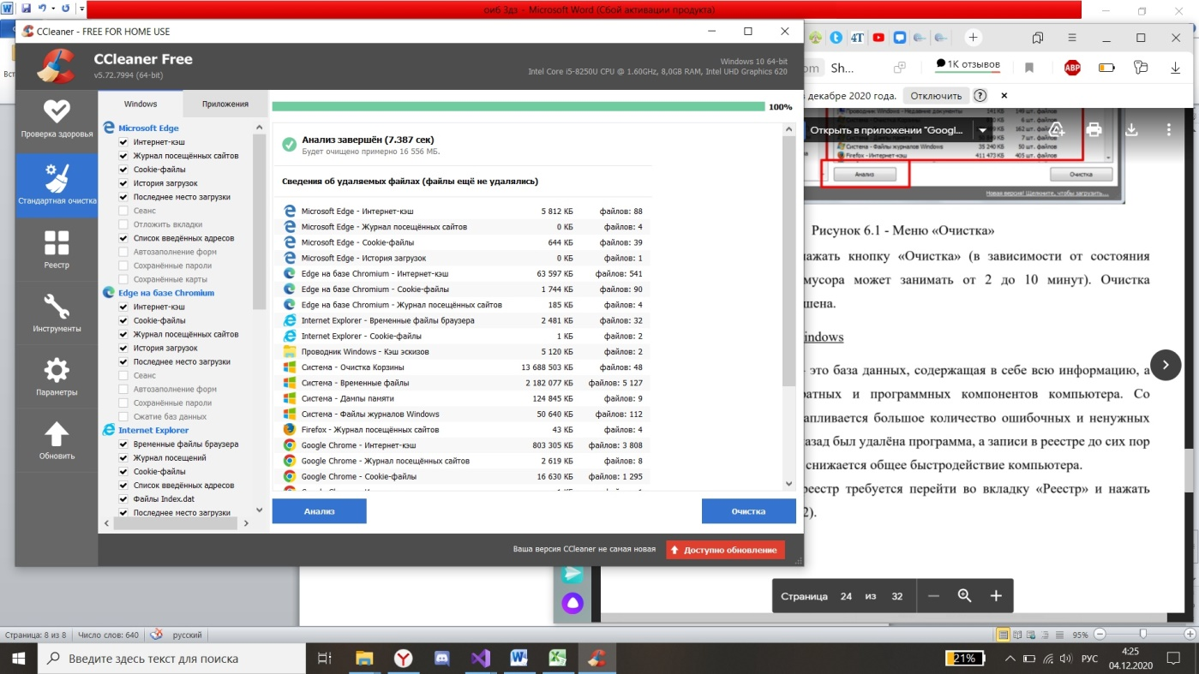



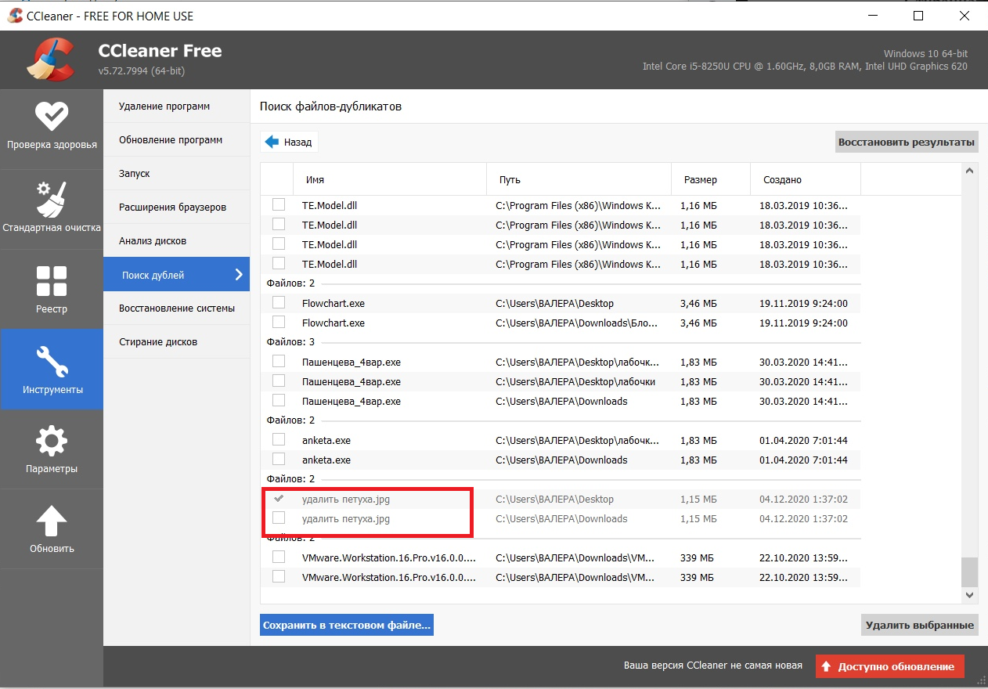

**Задание 4.**

Только один диск на компуктере, простите(